CHAPTER 1V
FINDING AND DISCUSSION

In this chapter, the researcher will describe the findings from the instrument during the teaching learning process and discuss about the use of Authentic materials for descriptive text in teaching speaking at the tenth grade of SMA Antartika Sidoarjo. The result of observation will be used to answer the problems of the study which have been stated in chapter 1.

4.1. Finding
The researcher described the teaching and learning process of the use of authentic materials for descriptive text in teaching speaking at the tenth grade of SMA Antartika Sidoarjo. The aim of this chapter is to find the answer based on the statement of the problem in this thesis, are as follows: (1) How is the implementation of using authentic materials for descriptive text in teaching speaking at the tenth grade of SMA ANTARTIKA Sidoarjo? (2) How are the students’ responses toward the use of authentic materials for descriptive text in teaching speaking at the tenth grade of SMA ANTARTIKA Sidoarjo?
The researcher did the observation two times, there were; Friday, July ${29}^{th}$ and ${30}^{th}$ 2016, the setting of this research on X MIPA 3 class students of SMA Antartika Sidoarjo in academic year 2016/2017. In line with the result of research questions, the data of using Authentic materials in teaching learning process implementation in the X MIPA 3. There were 50 students in there 27 females and 23 males.
The observation was held on 07.45 to 09:15 am the time allocation was 2x45 minutes. Furthermore, the teacher who implemented the Authentic materials was Mrs. Yuvita Carolin, S.Pd. The instrument which were used by the researcher to get data of using Authentic materials to teach speaking descriptive text to the tenth grade students SMA Antartika are observation checklist, questionnaire to the students, and interview to the teacher.
In the implementing of the Authentic materials, the teacher showed the materials of descriptive text. The teacher prepared all the stuff by herself. Starting from preparing the Authentic materials and giving task to the students. In this observation, the researcher was became the observer who was not taught in the teaching learning activity.
The researcher did not take any action or activity (during the process of teaching learning). The researcher only sat at the back, observed teaching learning process and taking notes. The researcher collected the data from two times meetings, the result were as follows:

4.1.1. The implementation of using Authentic Materials for Descriptive Text in Teaching Speaking
The implementation of using the authentic materials was held two times meetings. In the first meeting, it discussed about explanation of the descripteve text by using the authentic materials, and making students’ groups, and also several groups was performed. In the second meeting, it continued the students’ perform before, and took the questionnaires. The researcher interviewed the teacher in the last time while the students answered the questionnaires.

- The first meeting
- Pre-Activity
The researcher conducted the first meeting on Friday, July ${29}^{th}$ 2016. The time allotment was 2x45 minutes. The class began at 07.45 a.m. Before starting the lesson, the teacher greeted to the students. They said loudly and enthusiastic when answer the question. Than the teacher checked student’s attendance list.
Teacher : Good morning my lovely students!
Students : (all of the students) Good morning mam.
Teacher : How are you today?
Students : Iam fine, and you mam??
Teacher : good!!! I am very well, Thank you!!
who is absent today?
Student : No one mam!!!
Teacher : okey thaks

- Whilst – Activity
The teacher asked the students some question related to the descriptive text.
Teacher : “Okay class, do you know what the descriptive text is?”
Students : (some students answer) “text that explain something”
Teacher :” Good, and do you know what the authentic materials is?”
Students : (all students are Silent)

After the short conversation, the teacher explained clearly about definition of descriptive text, language features, and generic structures. According (Wardiman, 2008: 122) Descriptive text is a kind of text which describes particular thing, animal, person, or others, for instance: our pets or a person that is known well. The language features of descriptive text are as follow:
- Focus on one specific object
- The Use of Simple Present Tense
- The Use of Adjectives
The specific function of descriptive text is to give description about an object (human or non-human) (Pardiono, 2007: 34). The generic structures of descriptive text are the special characteristic of language in the text.
The generic structures of descriptive text are as follow:
- Identification
It is part of paragraph which introduces or identifies the character to be described. It can be called general description of the subject. Usually it contains object’s name, kind of the object, etc.
- Description
It is part of paragraph which describes parts and characteristics of the person or something that will be described in detail, so the readers can get clear description of the subject.
Here the example of the descriptive text:
“This paper is kind of the receipt. Its name is parking ticket. The shapes of parking ticket is square. There are some information in it. It shows the area of it is in Graga Bukopin Surabaya ,Jl.Panglima Sudirman. The tipe of vehicle is motorcycle with the number N6001YQ. Entrance time on 04.11.2016 at 11:27:18, and exit time on 04.11.2016 at 12:53:05. Then the duration time is 1 hour, 25 minutes and 47 second. It cost Rp.2.400, and parking taxt 25% or Rp.600. The total of parking price is Rp.3.000.”
Then definition of authentic materials according Jacobson et al (2003, p. 1) sees authentic materials as printed materials, which are used in classrooms in
the same way they would be used in real life.

Here the example of the authentic materials :
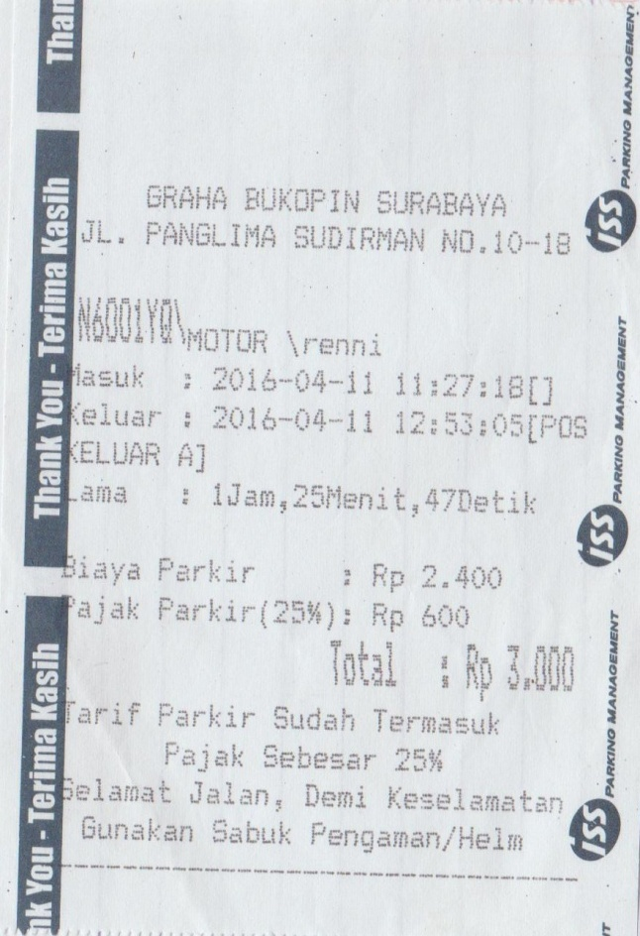
During teaching learning process the teacher spoke English but sometimes the teacher still translated to Indonesian because some students still confused in a few words and they did not know the meaning.
The teacher asked the student to pay attention the object authentic material (receipt) that showed and wrote on the white board with detailed and clearly. And then the teacher asks the students about the name of the object authentic materials. The students said it was receipt. But, they did not know what can do with them.
When the teacher presented the lesson, the situation was quite and the students listened to the teacher. After the teachers explained the materials, some students asked for time to understand the materials. Then the teachers divided the students become 10 groups. Each group consists of five students. From the group that had been formed later the teacher would like to choose one to describe the authentic material that they get. The teachers gave a different authentic material such as (atm receipt, bill, parking ticket, bus ticket, flight ticket, voucher, struck ect.) to each group.
The teacher just suggests the students to understand the materials and then discuss the result of description. For the performer the teacher called the name students on each group to describe they authentic materials in front of the class. Then students which finished present should have written the discussion result with the group.
- Post- Activity
It was 09.15 a.m it mean that only 5 groups could perform today. The other 5 groups performed at the following day. The teacher asked the students to finish their task and their discussion. After that the teacher added explanation about how the student can describe the sequence information from their authentic materials. Before the time was up the teacher asked the students about the difficulties during all process and discussed in this class.
After that the teacher made conclusion about the lesson today. The teacher ended the class and greeted to the students and leaving from the class.
- The second meeting
- Pre- Activity
This research conducted the second meeting on July${30}^{th}$, 2016. The observation for 2 X 45 minutes. The class began at 10.00 a.m. the teacher and researcher came to the class together. The teacher and researcher observed the teaching learning process. Before starting the lesson the teacher greeted to the students. The teacher asked who is absent today in class, and the students said that all the students attended.
Here is the conversation when the teacher opened the class:
Teacher : Good morning my lovely students!!!!
Students : (all of the students) Good morning mam.
Teacher : How are you today?
Students : Iam fine, and you mam??
Teacher : good!!! I am very well, Thank you!!
who is absent today?
Student : No one mam!!!
Teacher : okey thaks

- Whilst – Activity
When the teacher started this meeting the situation in the class was crowded. Some of students talk with each other.
To make class situation silent, the teacher say “Hello students” and then most of the student answered “Hai mam” Then the teacher asked to the students about descriptive text using authentic materials which has been discussed in the previous meeting.
Teacher : “Well, before we start our lesson, I want to recall you understanding about what we had in the previous meeting. What is the descriptive text?”
Students : (one of the students stand up) “Descriptive text is a kind of text which describes/explain something detailed and clearly and authentic materials is material objects than often exist in daily life”
Teacher : (with enthusiast) “very good!!! Sit down please, and now please mention some examples from authentic materials!
Students : (most of them mention) “bank receipt, parking ticket, struck, and boarding pass, bus ticket, nota.

In the review of the previous lesson, most of the student looks enthusiast event they answer the teacher question.
After that the teacher asked the students to gather with their groups as the previous day, the teacher called one of group members. It took for about 40 minutes. After finishing the performance by each group, the teacher and the observer delivered the questionnaire to the students to know the students responses after using authentic materials for descriptive text in teaching speaking.
While waiting for the students finishing to fulfill the questionnaire, the observer interviewed the teacher to know the opinion about the implementation of using authentic materials for descriptive text in teaching speaking in the class and also to know the teacher opinion about the students’ responses
- Post- Activity
It was 11.15 a.m. The teacher finished the class by asking their responses toward the using Authentic materials for descriptive text in teaching speaking in the class. After that, the teacher gave feedback about the lesson today and also remembered the student to always study hard.
The teacher hoped that they could get something meaningful from the activity. Finally the teacher ended the class and greeted to the students and leaving from the class.
4.1.2. The student’s response toward the implementation of using authentic materials for descriptive text in teaching speaking
In order to know the student’s response toward the implementation of using authentic materials for descriptive text in teaching speaking, the researcher used questionnaire. The questionnaire was given at the second meeting after the students finished their main activity. It took about 15 minutes for 50 students answered the questionnaire.
After the students finished answering the questionnaire, the researcher collected it. The result of the students responses is showed from the students answeres. The researcher collected the data based on the number of question and baded on the students’ answeres (yes/no answeres). After that the researcher entry the data to the table which prepared.
Here is the result of students response based on the questionnaires that finished to fulfil by all of the students and finished to count by the researcher:

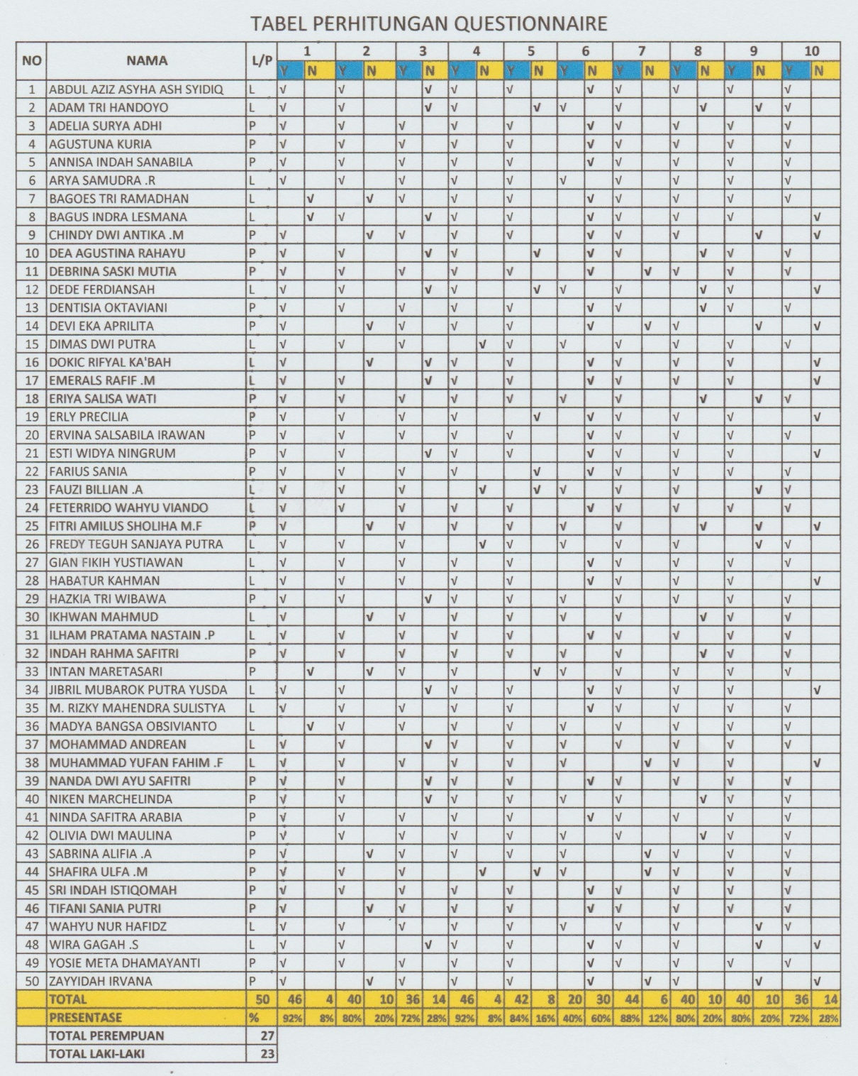
N= No
Y= Yes

Here is the questionnaire and the percentages:
- Do you like study English? (Apakah anda senang dengan pelajaran bahasa inggris?)
Students Response | Frequency | Percentage (%)
Yes (Iya)  No (Tidak) | 46  4 | 92%  8%
Total | 50 | 100 %

- Do you like speaking skill in English? ( Apakah anda senang terhadap pembelajaran speaking dalam bahasa inggris?)
Students Response | Frequency | Percentage (%)
Yes (Iya)  No (Tidak) | 40  10 | 80%  20%
Total | 50 | 100 %

- Do you get difficulties in studying speaking in English? ( Apakah anda memiliki kendala dalam belajar speaking dengan bahasa inggris?)
Students Response | Frequency | Percentage (%)
Yes (Iya)  No (Tidak) | 36  14 | 72%  28%
Total | 50 | 100 %

- Do you understand about descriptive text? (Apakah anda mengetahui apa it descriptive text?)
Students Response | Frequency | Percentage (%)
Yes (Iya)  No (Tidak) | 46  4 | 92%  8%
Total | 50 | 100 %

- Is learning speaking using descriptive text with authentic marterials media interesting for you? ( Apakah pembelajaran speaking menggunakan descriptive text dengan media authentic materi menarik bagi anda?)
Students Response | Frequency | Percentage (%)
Yes (Iya)  No (Tidak) | 42  8 | 84%  16%
Total | 50 | 100 %

- Did your teacher ever use descriptive text with authentic materials media in learning English speaking? ( Apakah guru anda pernah menggunakan descriptive text dengan media authentic untuk mengajar speaking?)
Students Response | Frequency | Percentage (%)
Yes (Iya)  No (Tidak) | 20  30 | 40%  60%
Total | 50 | 100 %

- Does the authentic materials in descriptive text make you easier in learning speaking? (Apakah penggunaan authentic materi dalam descriptive text membantu memmudahkan anda dalam pembelajaran speaking?)
Students Response | Frequency | Percentage (%)
Yes (Iya)  No (Tidak) | 44  6 | 88%  12%
Total | 50 | 100 %

- Do you enjoy learning speaking using descriptive text with authentic materials media? ( Apakah anda menikmati pembelajaran speaking menggunakan descriptive text dengan media authentic materials? )
Students Response | Frequency | Percentage (%)
Yes (Iya)  No (Tidak) | 40  10 | 80%  20%
Total | 50 | 100 %

- Do you think the use of Authentic materials in descriptive text motivates you so much in learning speaking? ( Apakah menurut anda penggunaan authentic materials dalam descriptive text sangat memotivasi anda dalam pembelajaran speaking? )
Students Response | Frequency | Percentage (%)
Yes (Iya)  No (Tidak) | 40  10 | 80%  20%
Total | 50 | 100 %

- Do you agree if learning speaking using descriptive text with authentic materials media is applied in the classroom? ( Apakah anda setuju pembelajaran speaking menggunakan descriptive text dengan media authentic materi di terapkan di kelas? )
Students Response | Frequency | Percentage (%)
Yes (Iya)  No (Tidak) | 36  14 | 72%  28%
Total | 50 | 100 %

According to the table of the questionnaires above, here are the explanations. At the first table, it can be described that there is 92% that likes English lesson, so the other dislikes the english lesson. Then, the percentage of the students that like in English speaking is 80%, but there is 20% of the students that dislike english speaking. On the third table, it can be interpreted that the students percentage that has the difficulties in learning speaking in english is 72%.
In the fourth questionnaire, there is 92% of the students that understand about descriptive text, meanwhile there is 8% of the students that do not understand about the descriptive text. The next questionnaire table describes that there is 84% of the students that answer that learning speaking using descriptive text by the authentic material is interesting. Unfortunately, on the sixth questionnaire it is only 40% of the students that answer that the teacher never used the descriptive text by using the authentic media for learning speaking.
For the seventh questionnaire, there is 88% of the students that answer that the use of the authentic materials in the descriptive text makes the students easier. On the eighth table, there is 80% that the students answer that the students enjoy learning speaking using the descriptive text by the authentic materials. For the nineth questionnaire, it is explained that there is 80% of the students that answer that the use of the authentic materials in the descritive text motivates so much in learning speaking. The last questionnaire table describes that there is 72% of the students that answer that the students agree if learning speaking using the descriptive text by the authentic matereials is applied in the classroom.
4.1.3 The Result of Interview with the Teacher
The researcher also interviewed the teacher to know the students difficulties in English class, the media in teaching speaking descriptive text, and the students response when using authentic materials for descriptive text in teaching speaking.
Based on the teacher answer, the teacher usually taught the descriptive text by using the commenting such as picture or photo of the ideal, person, animals and place, but the students that had the difficuties in learning speaking were commonly the students that felt afraid with the wrong grammar, and less vocabulary, and pronounciation. The teacher never used authentic material media for descriptive text in teaching speaking before. And after the teacher apply it for the first time in the class, the teacher found that the students felt so enthusiastic because it was a new media for descriptive text in teaching speaking. The teacher told that it could help the students, because the students could read the information what they were going to speak while looking at the authentic materials, without the students wrote first. Here is the paper of the result of interview with the teacher.

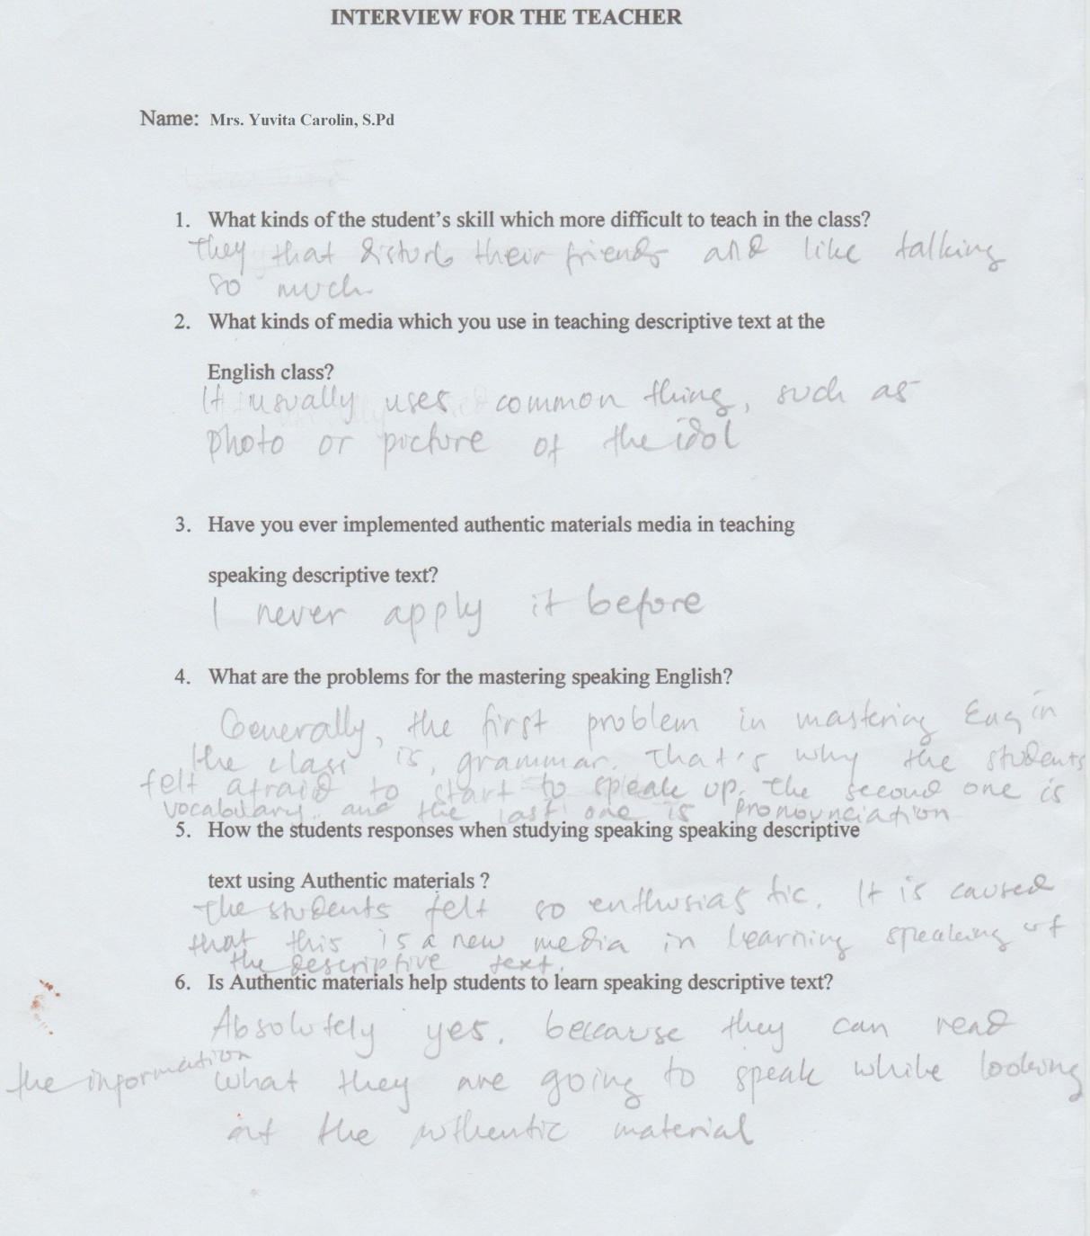

4.2 Discussion
In this part the researcher discussed about description of using authentic materials for descriptive text in teaching speaking at the tenth grade of SMA ANTARTIKA Sidoarjo. This section presented the discussion of researcher finding as the final reflection.
4.2.1 The implementation of using authentic materials for descriptive text in teaching speaking.
a. In the first meeting
The researcher observed the teacher when the teacher explains the materials and practice. The teacher explains about definition of descriptive text such as the meaning, generic stucture and language feature. In language features, the teacher explain about simple prasent tanse that used in descriptive text. The teacher also explained about authentic materials such as definition, form, and some examples from the authentic materials. Then the teacher explain how to use authentic materials for descriptive text in teaching speaking.
The researcher conducted the first meeting on Friday, July ${29}^{th}$ 2016. The time allotment was 2x45 minutes. The class began at 07.45 a.m. Before starting the lesson, the teacher greeted to the students. They said loudly and enthusiastic when answer the question. Than the teacher checked student’s attendance list.
Here the conversation related the opening :
Teacher : Good moorning students?
Students : Good moorning mam.
Teacher : How are you today?
Student : I am fine, and you?
Teacher : I am very well, thak you
who is absent today?
Student : No one mam!!!
Teacher : okey thaks

The teacher asked the students some question related to the descriptive text.
Teacher : “Okay class, do you know what the descriptive text is?”
Students : (some students answer) “text that explain something”
Teacher :” Good, and do you know what the authentic materials is?”
Students : (all students are Silent)

After the short conversation, the teacher explained clearly about definition of descriptive text, language features, and generic structures. According (Wardiman, 2008: 122) Descriptive text is a kind of text which describes particular thing, animal, person, or others, for instance: our pets or a person that is known well. The language features of descriptive text are as follows:
- Focus on one specific object
- The Use of Simple Present Tense
- The Use of Adjectives
The specific function of descriptive text is to give description about an object (human or non-human) (Pardiono, 2007: 34). The generic structures of descriptive text are the special characteristic of language in the text.
The generic structures of descriptive text are as follow:
- Identification
It is part of paragraph which introduces or identifies the character to be described. It can be called general description of the subject. Usually it contains object’s name, kind of the object, etc.
- Description
It is part of paragraph which describes parts and characteristics of the person or something that will be described in detail, so the readers can get clear description of the subject.
Here the example of the descriptive text:
The Parking Ticket
“This paper is kind of the receipt. Its name is parking ticket. The shape of parking ticket is square. There are some information in it. It shows the area of it is in Graha Bukopin Surabaya ,Jl.Panglima Sudirman. The tipe of vehicle is motorcycle with the number N6001YQ. Entrance time on 04.11.2016 at 11:27:18, and exit time on 04.11.2016 at 12:53:05. Then the duration time is 1 hour, 25 minutes and 47 second. It cost Rp.2.400, and parking taxt 25% or Rp.600. The total of parking price is Rp.3.000.”
Then definition of authentic materials according Jacobson et al (2003, p. 1) sees authentic materials as printed materials, which are used in classrooms in
the same way they would be used in real life.
Here the example of the authentic materials :
During teaching learning process the teacher spoke English but sometimes the teacher still translated to Indonesian because some students still confused in a few words and they did not know the meaning.
The teacher asked the student to pay attention the object authentic material (receipt) that showed and wrote on the white board with detailed and clearly. And then the teacher asks the students about the name of the object authentic materials. The students said it was receipt. But, they did not know what can do with them.
When the teacher presented the lesson, the situation was quite and the students listened to the teacher. After the teachers explained the materials, some students asked for time to understand the materials. Then the teachers divided the students become 10 groups. Each group consists of five students. From the group that had been formed later the teacher would like to choose one to describe the authentic material that they get. The teachers gave a different authentic material such as (atm receipt, bill, parking ticket, bus ticket, flight ticket, voucher, struck ect.) to each group.
The teacher just suggests the students to understand the materials and then discuss the result of description. For the performer the teacher called the name students on each group to describe they authentic materials in front of the class. Then students which finished present should have written the discussion result with the group.
It was 09.15 a.m it meant that only 5 groups could perform today. The other 5 groups performed at the following day. The teacher asked the students to finish their task and their discussion. After that the teacher added explanation about how the student can describe the sequence information from their authentic materials. Before the time was up the teacher asked the students about the difficulties during all process and discussed in this class. After that the teacher made conclusion about the lesson today. The teacher ended the class and greeted to the students and leaving from the class.
b. In the second meeting
The second meeting held on July${30}^{th}$, 2016. The observation walked for 2 X 45 minutes. The class began at 10.00 a.m. the teacher and researcher came to the class together. The teacher and researcher observed the teaching learning process. Before starting the lesson the teacher greeted to the students. The teacher asked who is absent today in class, and the students said that all the students attended. When the teacher started this meeting the situation in the class was crowded. Some of students talk with each other.
To make class situation silent, the teacher opened the meeting with the dialogues:
Teacher : “Hello students”
The student : “Hai mam”
Teacher : “Well, before we start our lesson, i want to recall you understanding about what we had in the previous meeting. What is the descriptive text?”
Students : (one of the students stand up) “Descriptive text is a kind of text which describes/explain something detailed and clearly and authentic materials is material objects than often exist in daily life”
Teacher : (with enthusiast) “very good!!! Sit down please, and now please mention some examples from authentic materials!
Students : (most of them mention) “bank receipt, parking ticket, struck, and boarding pass, bus ticket, nota.

In the review of the previous lesson, most of the student looks enthusiast event they answer the teacher question.
After that the teacher asked the students to gather with their groups as the previous day, the teacher called one of group members. It took for about 40 minutes. After finishing the performance by each group, the teacher and the observer delivered the questionnaire to the students to know the students responses after using authentic materials for descriptive text in teaching speaking. While waiting for the students finishing to fulfill the questionnaire, the observer interviewed the teacher to know the opinion about the implementation of using Authentic materials for descriptive text in teaching speaking in the class and also to know the teacher opinion about the students responses.
It was 11.15 a.m. The teacher asked the students to submited the paper of the questionnaires which have finish by the students, and the teacher finished the class by asking their responses toward the using Authentic materials for descriptive text in teaching speaking in the class. After that, the teacher gave feedback about the lesson today and also remembered the student to always study hard. The teacher hoped that they could get something meaningful from the activity. Finally the teacher ended the class and greeted to the students and leaving from the class.

4.2.2 The Result of the Questionnaire
In this part, the researcher discussed the result of the data from questionnaire. The data was the students’ opinion of the implementation of using authentic materials for descriptive text in teaching speaking.
According to the table of the questionnaire above, it could be explained that, At the first question, it described that there were 92% (46 students) that likes English lesson, so the other(4 students) dislikes the english lesson. Then, the percentage of the students that like in English speaking is 80%(40 students), but there is 20%(10 students) of the students that dislike english speaking. On the third question, it can be interpreted that the students percentage that has the difficulties in learning speaking in english is 72%(36 students), and 28%(14 students) they felt easy to learn English. In the fourth questionnaire, there were 92%(46 students) of the students understood about descriptive text, meanwhile there were 8%(4 students) of the students that did not understand about the descriptive text.
The next questionnaire described that there were 84%(42 students) of the students that answer that learning speaking using descriptive text by the authentic material is interesting. Unfortunately, on the sixth question there were 40%(20 students) of the students answered that the teacher never used the descriptive text by using the authentic media for learning speaking. It pointed that the use of authentic materials for descriptive text in teaching speaking was never used yet. For the seventh question, there were 88%(44 students) of the students answered that the use of the authentic materials in the descriptive text makes the students easier. On the eighth question, there were 80%(40 students) that the students answer that the students enjoy learning speaking using the descriptive text by the authentic materials. For the nineth question, it was explained that there is 80%(40 students) of the students that answer that the use of the authentic materials in the descritive text motivates so much in learning speaking. The last question describes that there were 72%(36 students) of the students answered that the students agree if learning speaking using the descriptive text by the authentic matereials is applied in the classroom.

4.2.3. The Result of the Interview
Based on the teacher’s answers, the teacher usually taught the descriptive text by using the commenting such as picture or photo of the ideal, person, animals and place, but the students that had the difficuties in learning speaking were commonly the students that felt afraid with the wrong grammar, and less vocabulary, and pronounciation. The teacher never used authentic material media for descriptive text in teaching speaking before. And after the teacher apply it for the first time in the class, the teacher found that the students felt so enthusiastic because it was a new media for descriptive text in teaching speaking. The teacher told that it could help the students, because the students could read the information what they were going to speak while looking at the authentic materials, without the students wrote first.

